Pizza Sales SQL Report
KPI’s
- Total Revenue
select sum(total_price) AS Total_revenue
from pizza_sales_orders
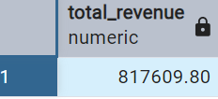

2 Total Orders
select count( distinct order_id)AS total_orders
from pizza_sales_orders
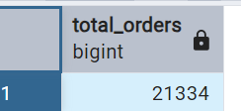

3 . Average order value
select round(sum(total_price)/count(distinct order_id),2) AS average_order_value
from pizza_sales_orders
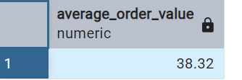

4. Total pizza sold
select sum(quantity) AS total_pizza_sold
from pizza_sales_orders
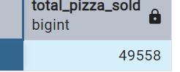

5. Average pizza per order
select round(sum(quantity)/count(distinct order_id),2)AS Average_Pizza_per_order
from pizza_sales_orders
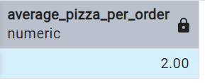

Analysis
- Monthly total Revenue Trend
select TO_CHAR(order_date,'MONTH') AS Month,sum(total_price)AS total_sales
from pizza_sales_orders
group by TO_CHAR(order_date,'MONTH')
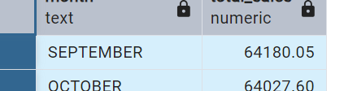

- Daily total Revenue trend
select TO_CHAR(order_date,'DAY')AS Day,count(distinct order_id)AS total_orders
from pizza_sales_orders
group by TO_CHAR(order_date,'DAY')
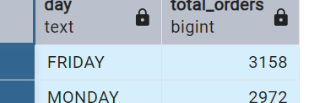
3.Percentage of sales by pizza category
select pizza_category,sum(total_price) AS total_sales,
Round(sum(total_price)*100/
(select sum(total_price) from pizza_sales_orders),2) As percentage_sale_by_pizza_category
from Pizza_sales_orders
group by pizza_category
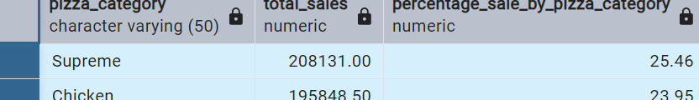

4 Percentage of Sales by Pizza size
select pizza_size,sum(total_price)AS total_sales,
Round(sum(total_price)*100 /
(select sum(total_price) from pizza_sales_orders),2)AS percentage_sale_by_pizza_size
from pizza_sales_orders
group by pizza_size
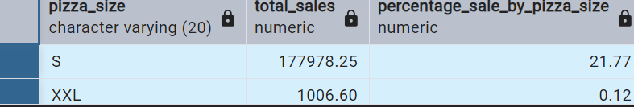

5. Total Pizzas sold by pizza size and category.
select pizza_size,sum(quantity)AS total_pizza_sold
from pizza_sales_orders
group by pizza_size
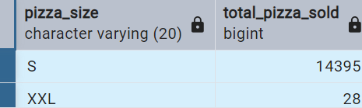

select pizza_category,sum(quantity)AS total_pizza_sold
from pizza_sales_orders
group by pizza_category
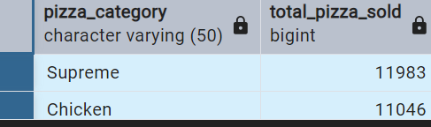

6. Revenue by pizza name
select pizza_name,sum(total_price)AS total_sales
from pizza_sales_orders
group by pizza_name
order by total_sales desc
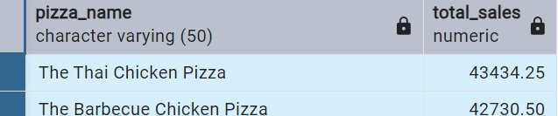

Top & Bottom Analysis
- Top pizza by Revenue
select pizza_name,sum(total_price)AS total_sales
from pizza_sales_orders
group by pizza_name
order by total_sales desc
Limit 5
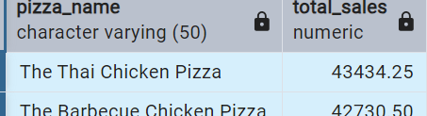

- Worst pizza by Revenue
select pizza_name,sum(total_price)AS total_sales
from pizza_sales_orders
group by pizza_name
order by total_sales asc
Limit 5
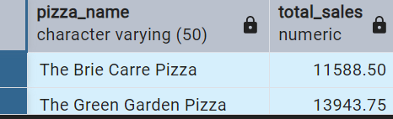
3 Top pizza by Orders
select pizza_name,count(distinct order_id)AS total_orders
from pizza_sales_orders
group by pizza_name
order by total_orders desc
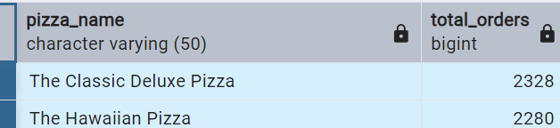

- Worst pizza by Orders
select pizza_name,count(distinct order_id)AS total_orders
from pizza_sales_orders
group by pizza_name
order by total_orders asc
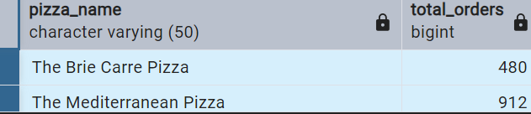

- Top pizza by quantity sold
select pizza_name,sum(quantity)AS total_quantity
from pizza_sales_orders
group by pizza_name
order by total_quantity desc

